

Holy Family University
Information Technology Department
User Proxy Runbook

September 2026

Table of Contents
Proxy Access Guide 3
Student Instructions 3
Adding a Proxy 3
Step 1 – Sign In to Self-Service 3
Step 2 – Open User Options 3
Step 3 – Add a Proxy 4
Step 4 – Enter the Proxy's Information 5
Step 5 – Select the Information the Proxy Can Access 5
Important Information About Payments 6
Step 6 – Review the Disclosure Agreement 6
Step 7 – Submit the Proxy Request 7
What Happens Next? 7
Proxy Did Not Receive the Email? 7
Proxy/Parent Instructions 8
Accessing a Student's Information 8
Step 1 – Review Your Proxy Email 8
Step 2 – Establish Your Access 8
Step 3 – Proxy Registration Result 9
After successful registration, the proxy will receive two emails: one identifying their username and another containing their temporary password. 10
Step 5- View Authorized Information 10
Changing Proxy Access and Removing Proxy Access 11
Changing Proxy Access 11
Removing Proxy Access 11
Frequently Asked Questions (FAQs) 12
Security Reminder 13
Need Help? 13

Proxy Access Guide
Proxy Access allows a student to give a parent, guardian, spouse, or another trusted individual permission to view selected information in Colleague Self-Service.
The student controls who receive proxy access and what information each proxy is permitted to view. Proxy access can be changed or removed by the student at any time.

Student Instructions

Adding a Proxy

Step 1 – Sign In to Self-Service
Sign in to Colleague Self-Service using your Holy Family University credentials.
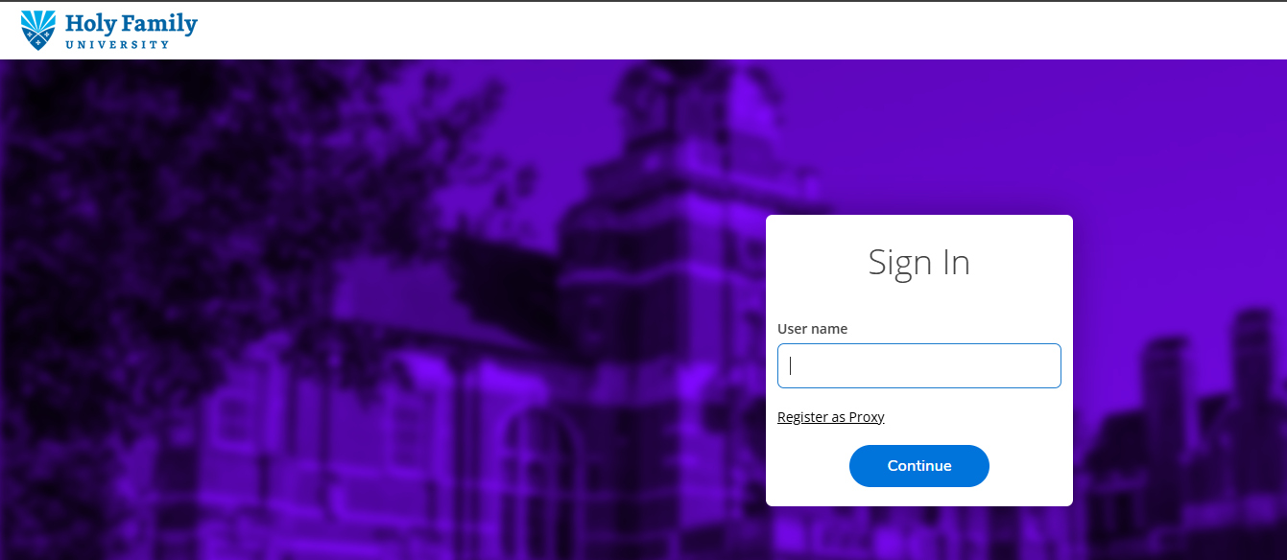

Step 2 – Open User Options
From the Self-Service navigation menu:
- Select User Options.
- Select View/Add Proxy Access.
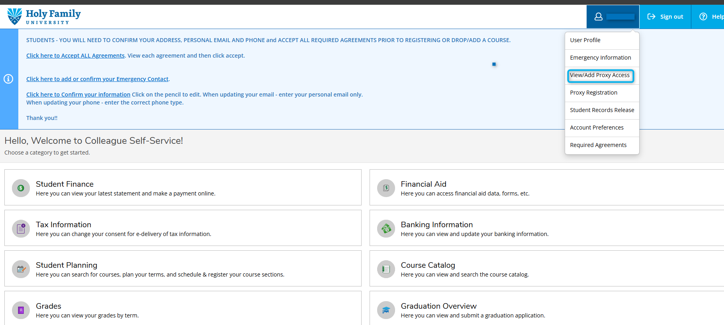

Step 3 – Add a Proxy
The View/Add Proxy Access page displays individuals who currently have proxy access and provides the option to add another proxy.
Under Add a Proxy, select the appropriate person from the Select a Proxy drop-down menu.
If the person you want to authorize is not listed, select:
Add Another User
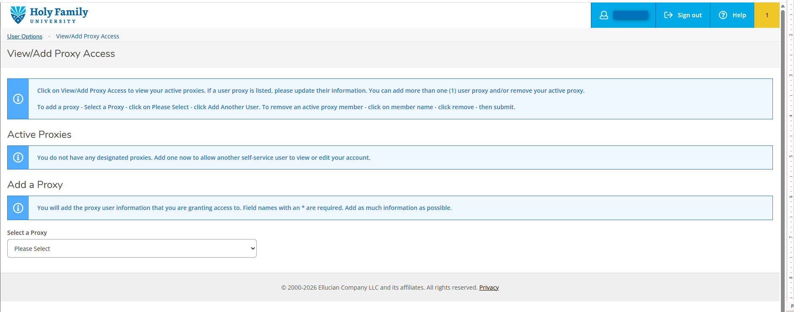

Step 4 – Enter the Proxy's Information
If you selected Add Another User, enter the requested information for the person you are authorizing.
Required information may include:
- First Name | - Last Name
- Email Address | - Confirm Email Address
- Relationship

Complete all fields marked as required.
Important: Enter the proxy's personal email address carefully.
Information about establishing proxy access will be sent to the email address entered on this screen.
Do not enter your own Holy Family University email address for the proxy.
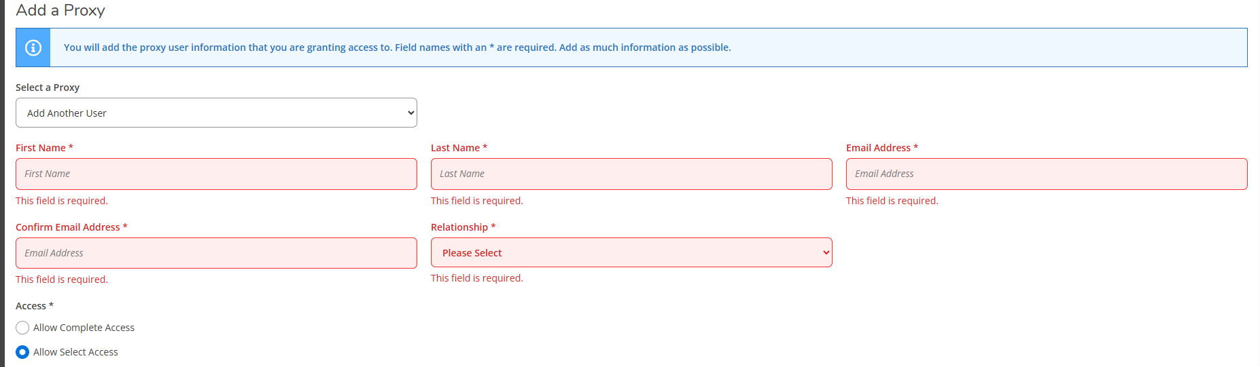

Step 5 – Select the Information the Proxy Can Access
Choose the information you want the proxy to view.
Depending upon the options available in Self-Service, these may include information related to:
Financial Information | Financial Aid Information
Academic Information | Grades
Tax Information | Required Documents
Notifications

Remember: You do not have to provide access to everything. The proxy can access only the information you specifically authorize.
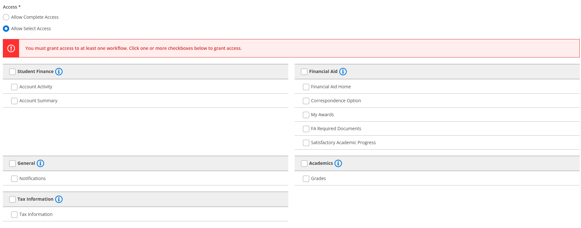

Important Information About Payments
Proxy Access and payment portal access are separate.
At this time, proxies are unable to make payments through the Payment Portal in Self-Service. Holy Family University is working to provide payment access for proxies in the future. Proxies seeking to make a payment can contact the Office of Student Accounts directly at 267-341-3202.

Step 6 – Review the Disclosure Agreement
Carefully review the authorization/disclosure information displayed in Self-Service.
By granting proxy access, you are authorizing Holy Family University to make the selected information available to the individual you have designated.
Complete the required authorization acknowledgment.
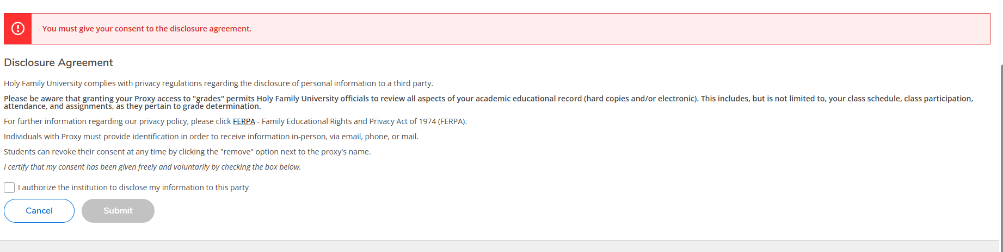

Step 7 – Submit the Proxy Request
After reviewing:
- Proxy’s Information | - Proxy Email Address
- Relationship | - Information you are authorizing
- Disclosure Agreement

Select Submit to process your proxy authorization.
Note: To add more than one proxy, repeat Steps 3 through 7 for each individual.

What Happens Next?
After proxy access is established, Self-Service sends information to the proxy using the email address provided by the student.
The proxy should carefully follow the instructions in the email.

Proxy Did Not Receive the Email?
Ask the proxy to:
- Verify that they are checking the email address you entered.
- Check their Spam, Junk, or Clutter folders.
- Allow time for the automated email to arrive.
You should also return to View/Add Proxy Access and verify that the proxy's email address was entered correctly.

Proxy/Parent Instructions

Accessing a Student's Information
You have received this communication because a Holy Family University student has authorized you to access selected portions of their information through Colleague Self-Service.

Step 1 – Review Your Proxy Email
Open the proxy access email sent to the email address provided by the student. Follow the instructions provided in your email to establish your credentials.
Do not use the student's Holy Family University username or password.

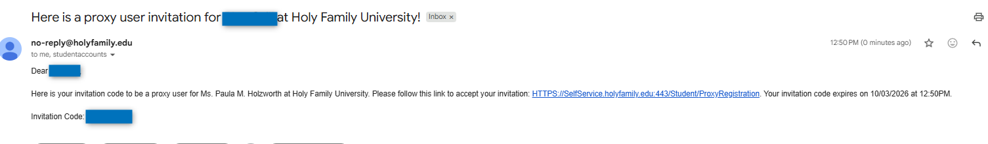

Step 2 – Establish Your Access
Complete the form and click Submit. Fill out the required fields marked with (*).
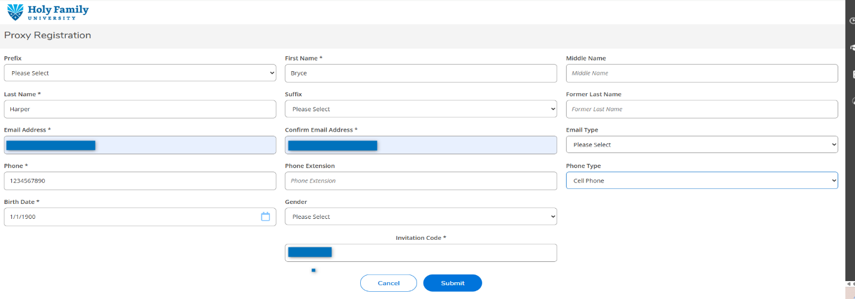

Step 3 – Proxy Registration Result
Once you click Submit, you will receive a notification that you are successfully registered as a proxy.
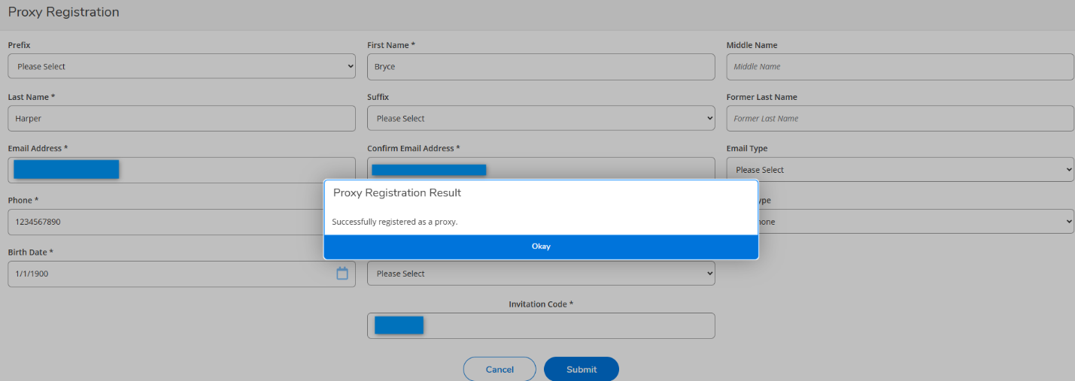
Step 4 – Proxy Emails

After successful registration, the proxy will receive two emails: one identifying their username and another containing their temporary password.

Username Email:
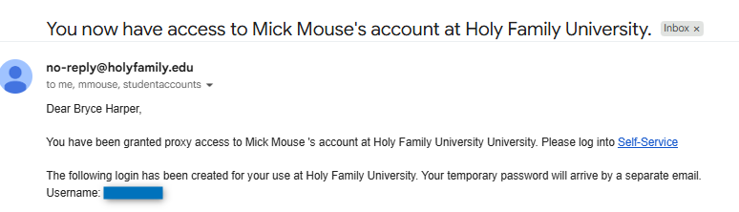

Temporary Password Email:
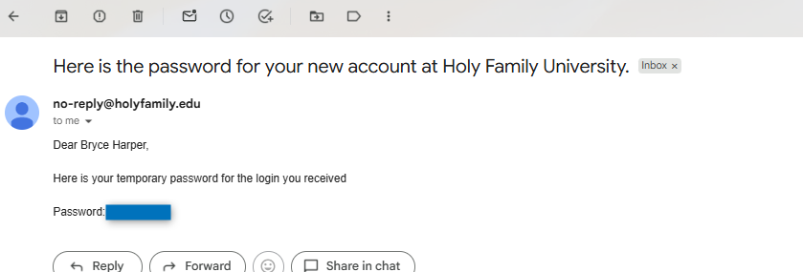

Step 5- View Authorized Information
You will see only the information the student has authorized you to access. The information available will depend on the permissions selected by the student:
Possible Permissions include:
Financial Information | Financial Aid Information
Academic Information | Grades
Tax Information | Required Documents
Notifications

The student determines which information is available to you.
- Add or remove permissions as appropriate.
- Click Submit to save your changes.
Changes to proxy access may generate an automated email informing the proxy that their access has been updated.
To remove:
- Select the option to remove the proxy.
- Follow the prompts to remove/revoke access.
- Confirm the change.
Once access is removed, the individual will no longer be authorized to view information previously shared with them via Proxy Access.

Frequently Asked Questions (FAQs)
- What is a proxy?
A proxy is a person whom you (the student) authorize to access select portions of your information through Self-Service.
A proxy could be a parent, guardian, spouse, or another trusted individual who you select.
- Does my parent automatically receive access?
No. Students must establish Proxy Access and select the information they want the proxy to see.
- Can I have more than one proxy?
Self-Service can support multiple proxies when permitted by the University's configuration. Each proxy can be assigned the appropriate access individually.
- Does my proxy see everything in my student record?
No. The proxy can view only the information you have authorized them to see and that Holy Family University has made available for Proxy Access.
- Can I change what my proxy can see?
Yes. Return to User Options > View/Add Proxy Access to review or change the permissions assigned to your proxy.
- Can I remove a proxy?
Yes. Students can remove proxy access when it is no longer needed.
- Does Proxy Access give someone my Holy Family University account?
No. Your proxy should never use your Holy Family University username or password.
Never share your University password with a parent, family member, proxy, or anyone else.
- Does my proxy receive a Holy Family University email account?
No. Proxy Access does not provide an individual with a Holy Family University email account.
- What if my proxy forgets their password?
The proxy should use the password/account recovery options associated with their proxy account or follow the instructions provided on the Proxy Self-Service sign-in page.
Students should not provide their Holy Family University password to a proxy as a workaround.

Security Reminder
Your Holy Family University username, password, and Multi-Factor Authentication information are for your use only.
Never share your University password or MFA authentication with anyone.
Proxy Access is the appropriate way to provide another person with authorized access to selected student information.

Need Help?
If you experience difficulty establishing or accessing Proxy Access, contact the HelpDesk for assistance.
When requesting assistance, please be prepared to provide:
- Full name | - Student ID Number
- Proxy’s Name | - Proxy Email Address
- Brief Description of the Issue

Never include passwords or Multi-Factor Authentication codes in an email or support request.

